Day 30
Task 1:
Create table in Dynamo DB:
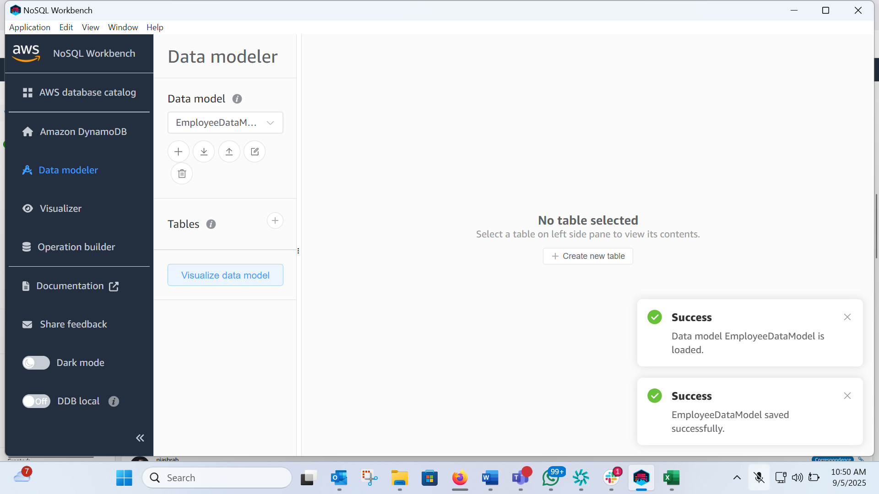
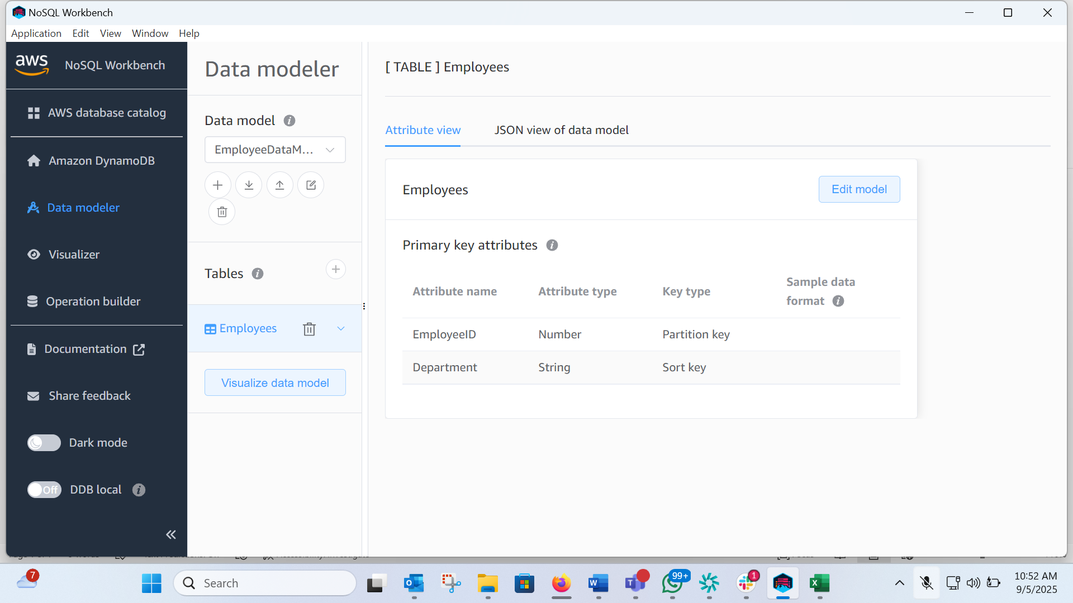
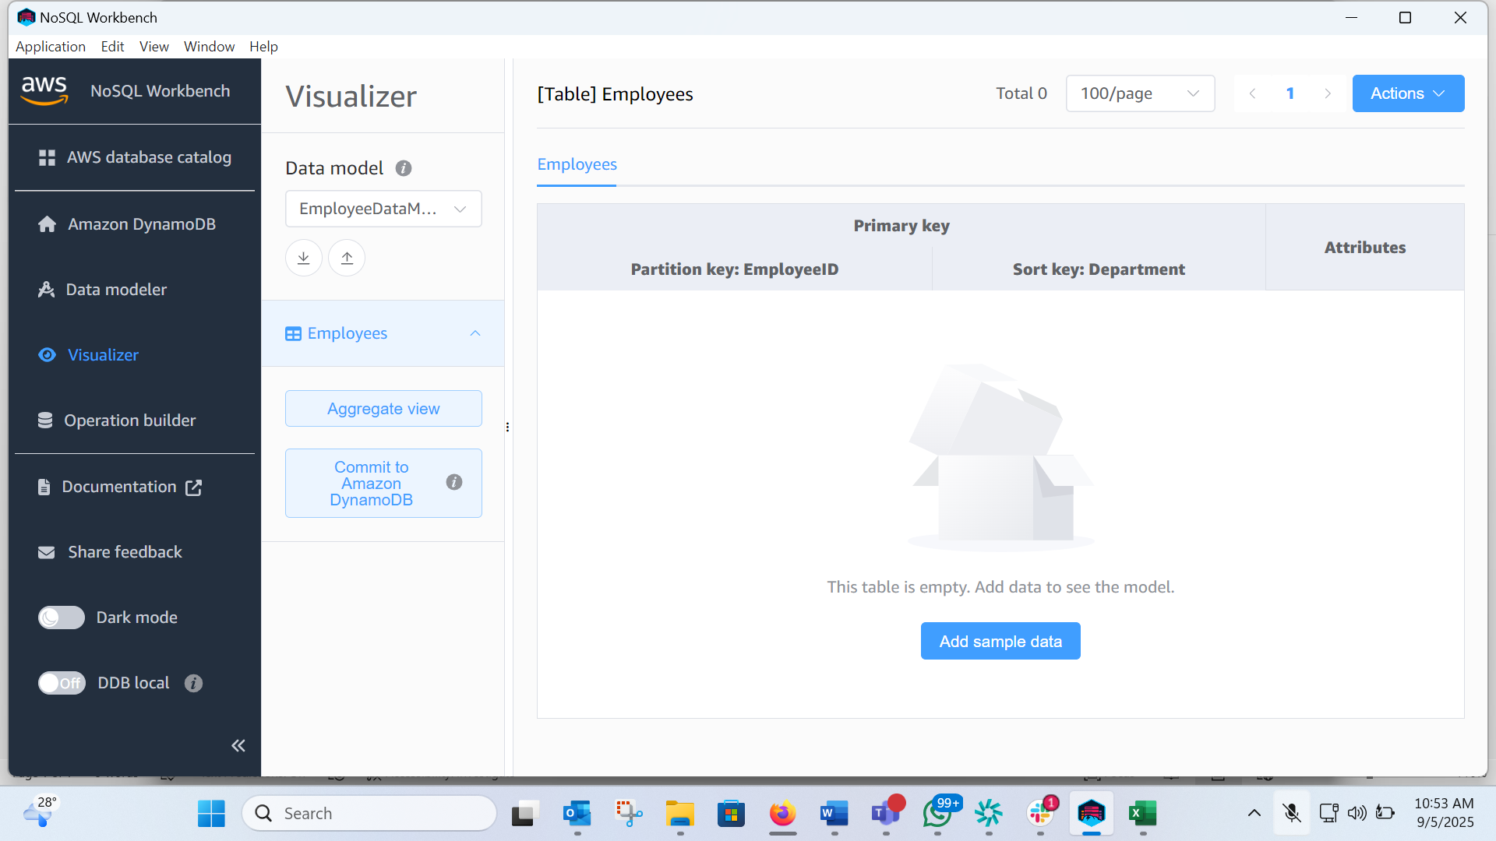
Task 3:
Create table in Dynamo DB:
aws dynamodb create-table \
--table-name EmployeeSpet \
--attribute-definitions AttributeName=EmpName,AttributeType=S AttributeName=EmpAddress,AttributeType=S \
--key-schema AttributeName=EmpName,KeyType=HASH AttributeName=EmpAddress,KeyType=RANGE \
--provisioned-throughput ReadCapacityUnits=1,WriteCapacityUnits=1
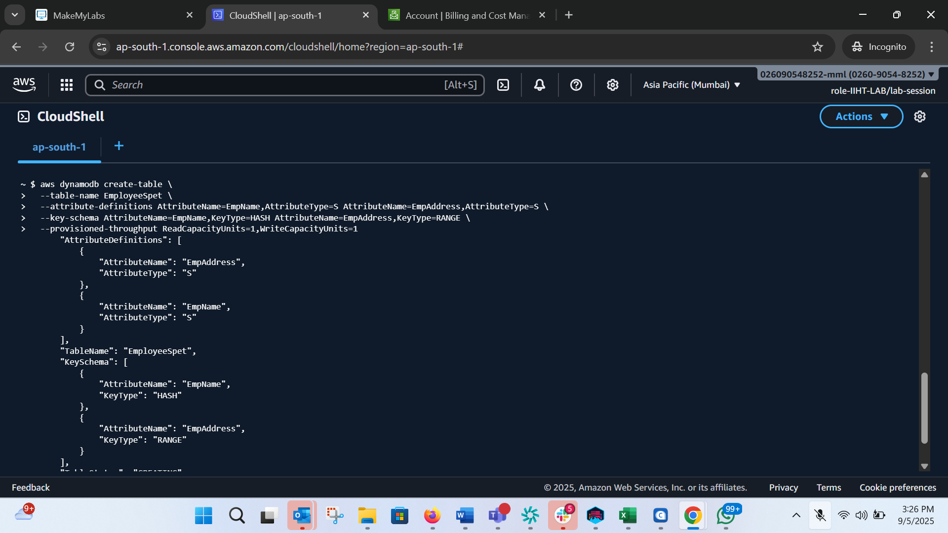
Added new item to the table:
aws dynamodb put-item --table-name EmployeeSpet --item '{"EmpName":{"S": "Nihar"}
, "EmpAddress":{"S": "India"}, "email": {"S": "aaa@bbb.com"}}' --return-consumed-capa
city TOTAL
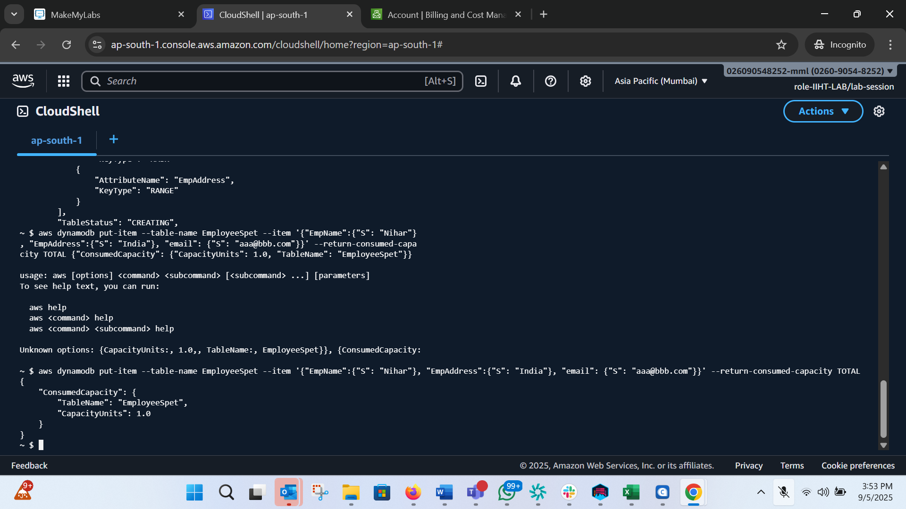

aws dynamodb create-table \
Preview --table-name 'Students' \
--attribute-definitions \
Done 'AttributeName=rollno,AttributeType=N' \
'AttributeName=Name,AttributeType=S' \
--key-schema \
'AttributeName=rollno,KeyType=HASH' \
'AttributeName=Name,KeyType=RANGE' \
--billing-mode PAY_PER_REQUEST

Resources:
Preview Students:
Type: "AWS::DynamoDB::Table"
Done Properties:
TableName: Students
AttributeDefinitions:
- AttributeName: rollno
AttributeType: N
- AttributeName: Name
AttributeType: S
KeySchema:
- AttributeName: rollno
KeyType: HASH
- AttributeName: Name
KeyType: RANGE
BillingMode: PAY_PER_REQUEST

Create table using Wizard: aws dynamodb wizard new-table
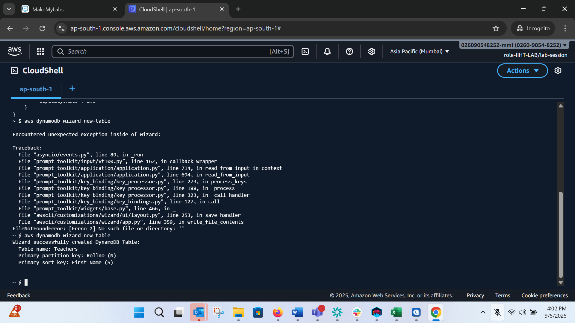
Deleting a table: aws dynamodb delete-table --table-name EmployeeSpet
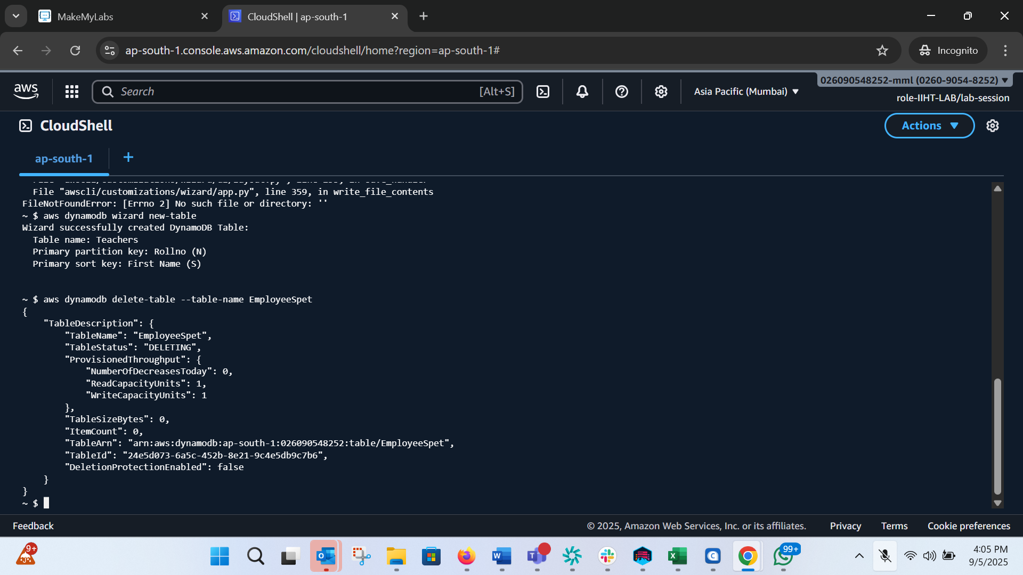
Checking if deleted: aws dynamodb list-tables
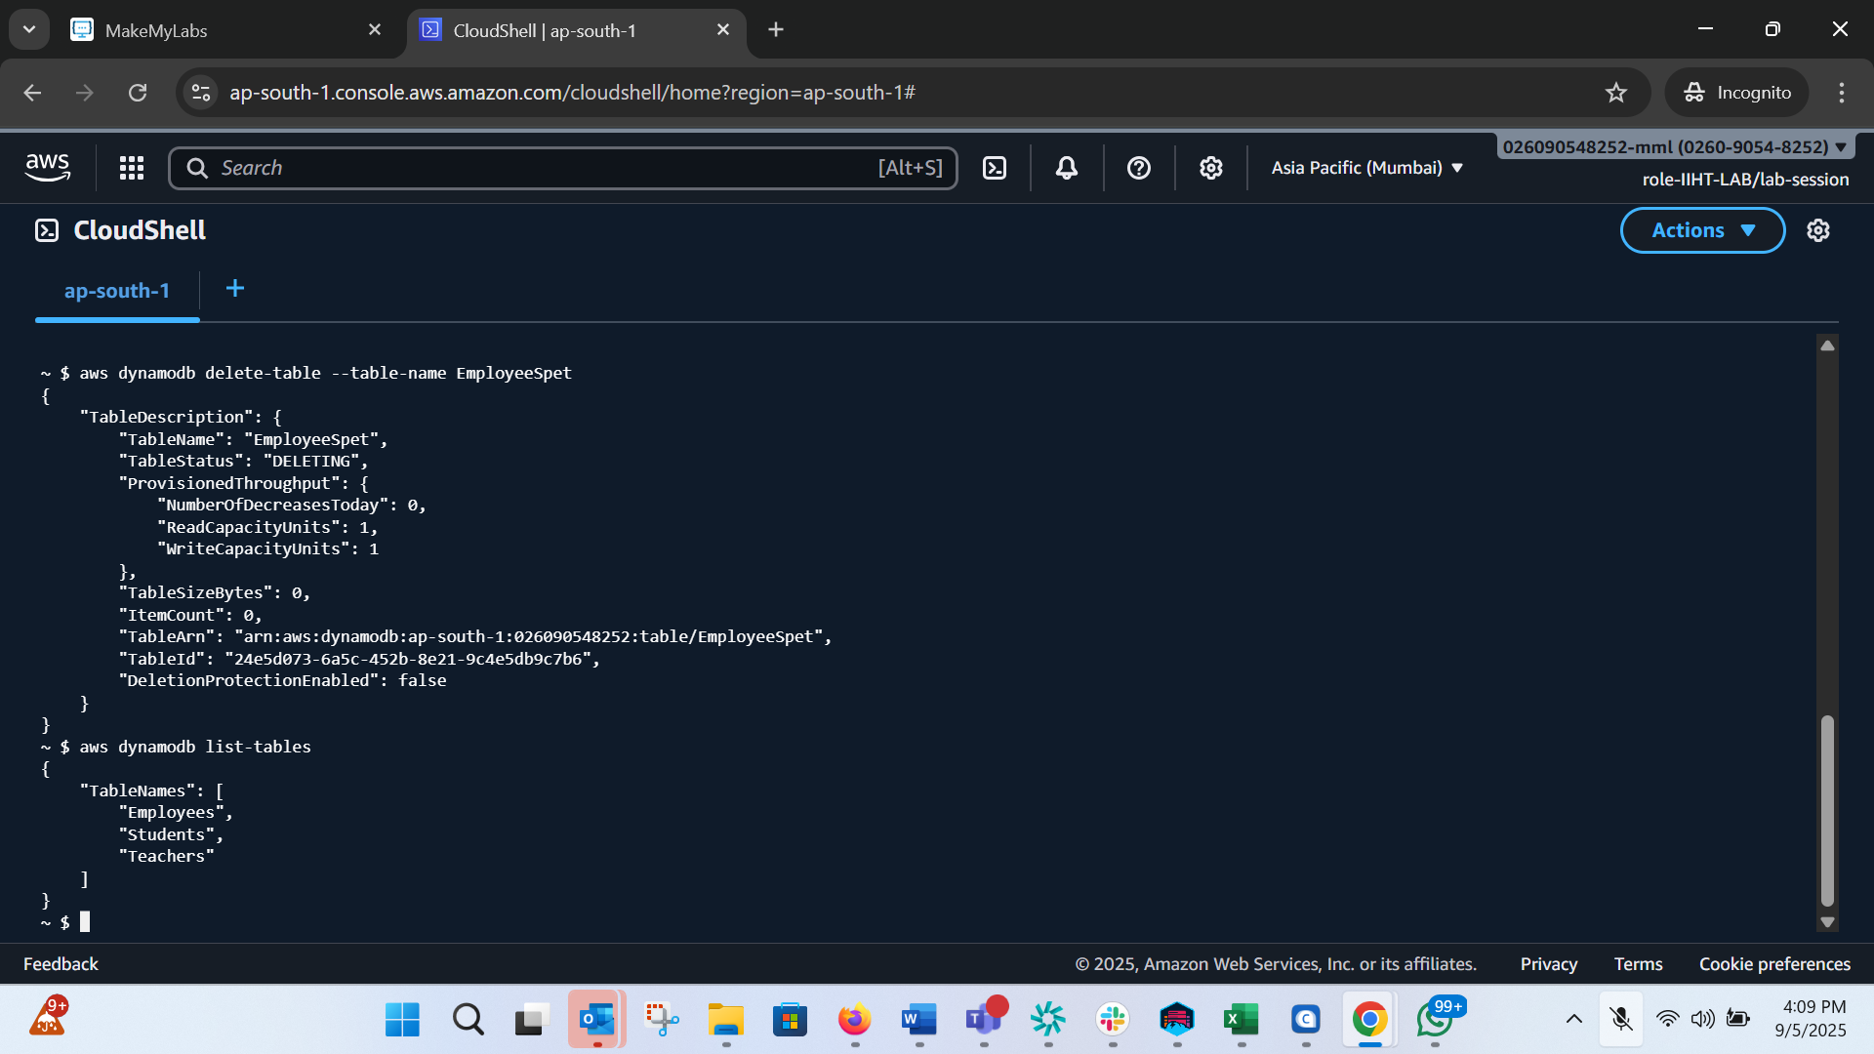
Details of a particular Table: aws dynamodb describe-table --table Students
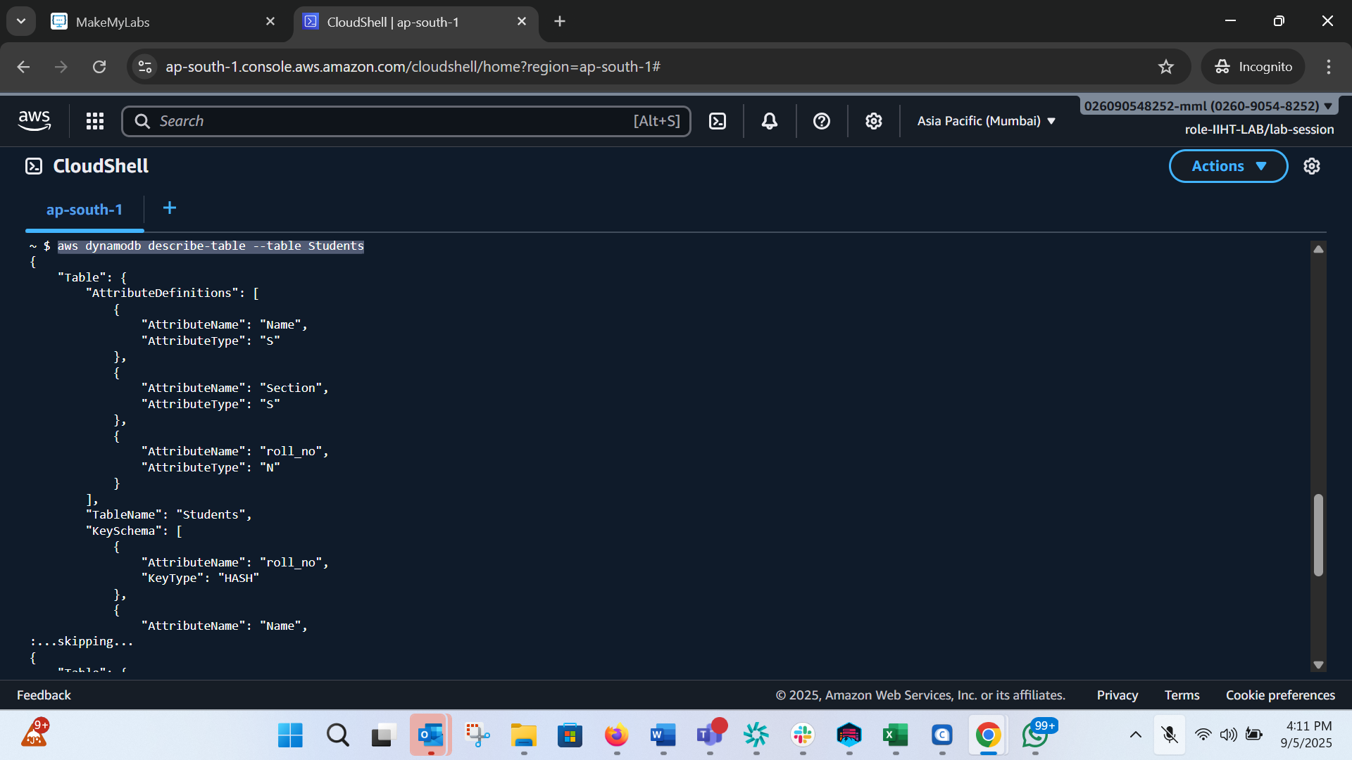
Back of table:
Can ask for full back up or on demand backup:
aws dynamodb create-backup --table-name EmployeeSpet --backup-name StudentbkUp
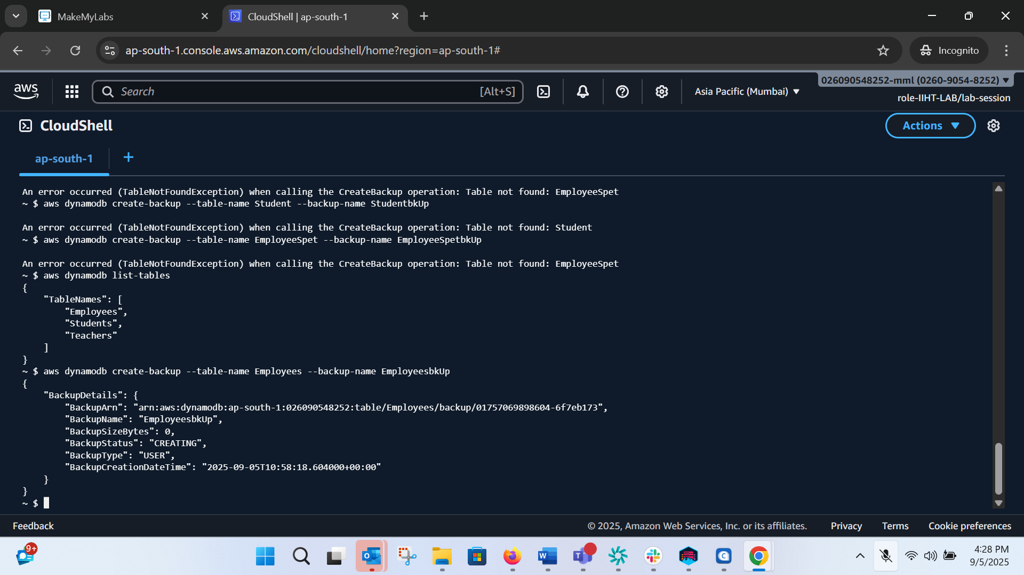
List backups:
aws dynamodb list-backups
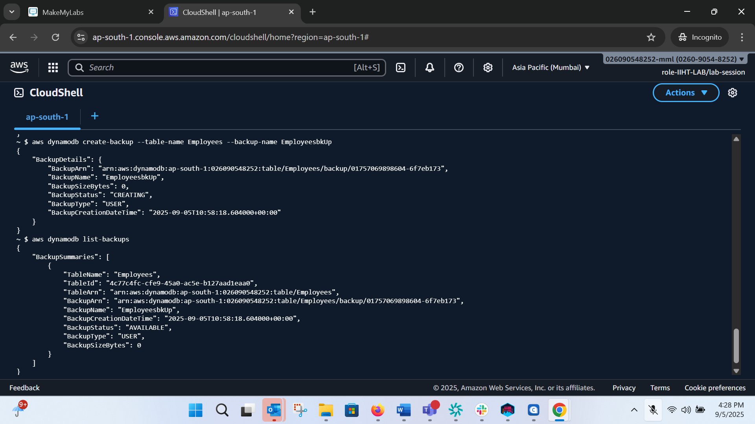
"TableName": "Employees",
"TableId": "4c77c4fc-cfe9-45a0-ac5e-b127aad1eaa0",
"TableArn": "arn:aws:dynamodb:ap-south-1:026090548252:table/Employees",
"BackupArn": "arn:aws:dynamodb:ap-south-1:026090548252:table/Employees/backup/01757069898604-6f7eb173",
"BackupName": "EmployeesbkUp",
"BackupCreationDateTime": "2025-09-05T10:58:18.604000+00:00",
"BackupStatus": "AVAILABLE",
"BackupType": "USER",
"BackupSizeBytes": 0

RESTORE TABLE FROM BACKUP:
aws dynamodb restore-table-from-backup --target-table-name restoreStudent --backup-arn arn:aws:dynamodb:ap-south-1:026090548252:table/Employees/backup/01757069898604-6f7eb173
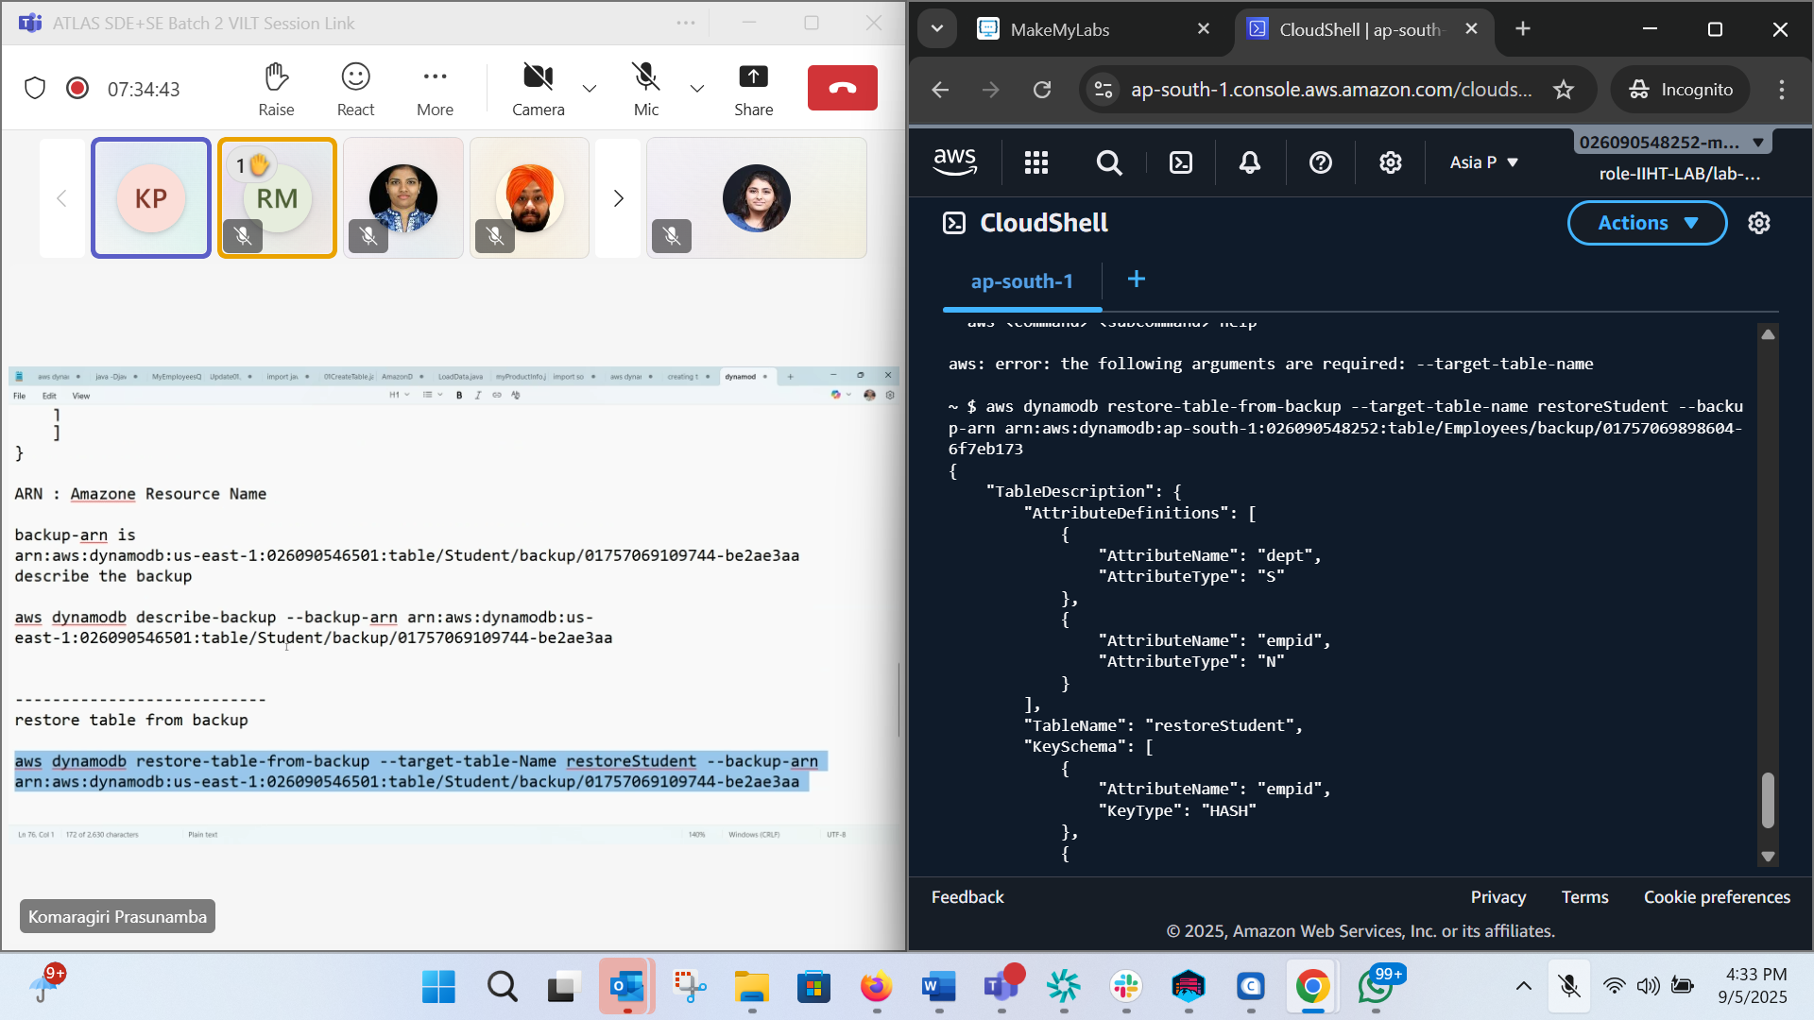
Scan/ getting all items in the table: aws dynamodb scan --table-name Employees
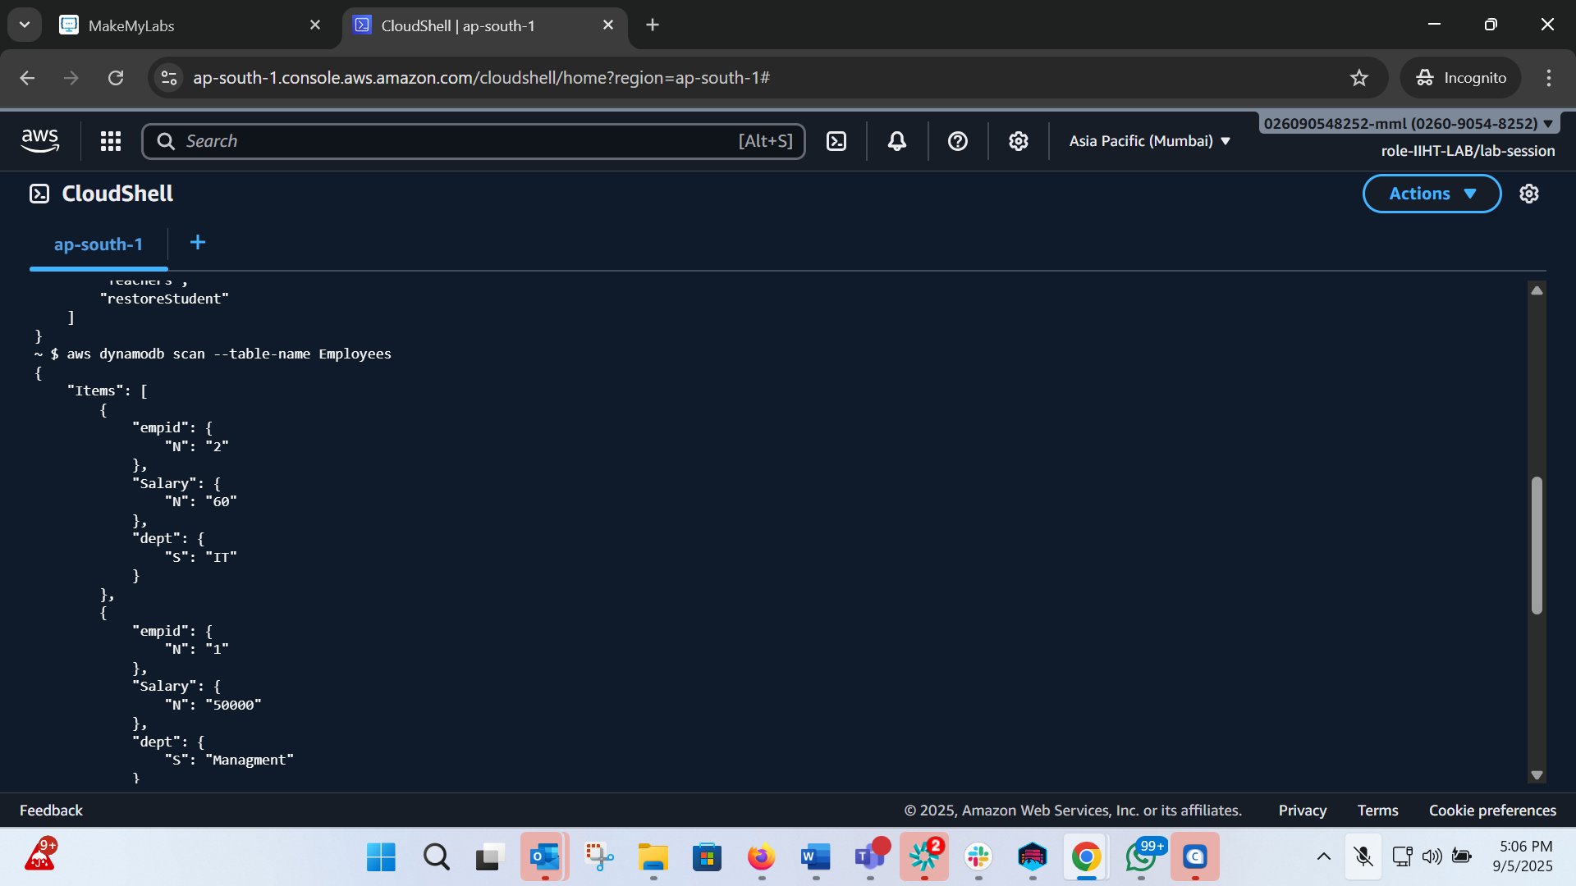
Put items: aws dynamodb put-item --table-name Teachers --item '{"Rollno":{"N": "1"}, "First Name":{"S": "John"}}'
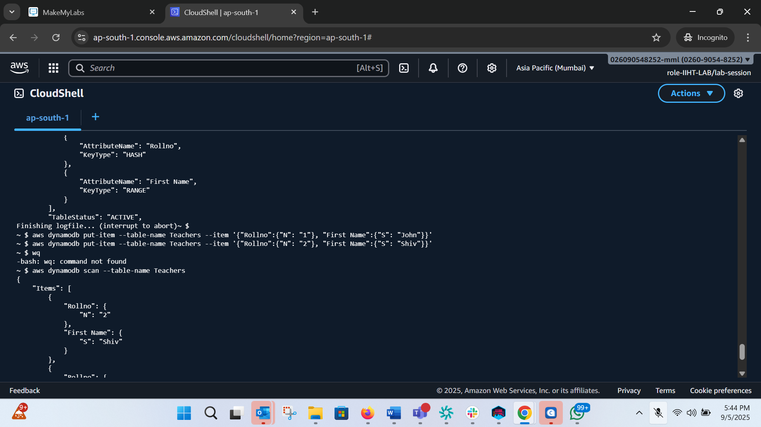
Get item: aws dynamodb get-item --table-name Teachers --key '{"Rollno":{"N": "1"}, "First Name":{"S": "John"}}'

